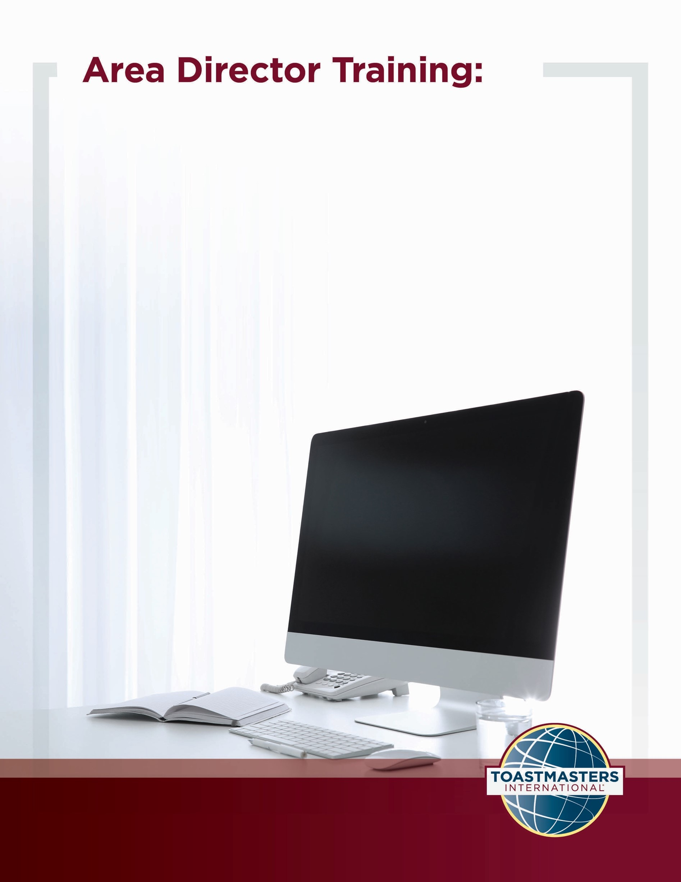

Effective Area Meetings

Location of the material: https://www.toastmasters.org/leadership-central/district-leader-tools/training/division-and-area-directors-training-materials

11/01/2021

Effective Area Meetings
Introduction
The purpose of this session is to identify problems with meetings and use sound strategies for being a good contributor and facilitator of meetings.
Overview
First, Area Directors reflect on past meetings and share what didn’t go well. Then, they review the seven shortcomings of meetings. Finally, they address each shortcoming by discussing best practices they can implement for future meetings.
In this session, facilitators discuss the following topics:
- What’s Wrong with Meetings?
- Meeting Best Practices
Objectives
After completing this session, Area Directors will be able to do the following:
- Identify barriers and best practices to having effective meetings
- Develop strategies to conduct effective meetings
By meeting these objectives, Area Directors will be able to understand and perform their role as a meeting member and a meeting facilitator to support their peers.
Materials
- PowerPoint
- Session Workbook PDF
Time
- 60 minutes

Session Preparation
- Familiarize yourself with the pre-work for this session, where Area Directors will:
Complete Questions to Consider
These questions promote reflection on their experiences and add depth to the discussion in each Breakout Room Activity and the Whole Room Discussions.
Complete Area Director Meetings Snapshot
- Review the entire Facilitator Guide.
You will find Notes to Facilitator throughout the guide which are informational and are not intended to be read aloud to participants. Use them to help formulate your talking points and identify your objectives.
This session may be delivered online through a video conference platform or in person. This guide contains tips and notes that you will need to apply to how the material will be delivered.
Throughout this guide, you will find highlighted yellow directions. These are callouts to what actions need to be taken when delivering this session online.
If you plan to conduct this session in person, some of the instructions or slides will no longer be applicable. Please review the materials carefully and update them to best suit the needs of your session format.
- Practice with your co-facilitator(s) to ensure smooth transitions throughout the session.
- Consider assigning a technical assistant to help with the logistics of the session and (breakout rooms, chat, technical issues, etc.) when delivering this session online.
- Review the instructions and materials for each Breakout Room Activity.
- There is a slide at the end of this session that gives five minutes for participants to fill out a survey. Consider creating a survey to gather feedback on your session or remove the slide.

Pre-Session
START the meeting 30 minutes ahead of time.
START sharing the slides.
Note to FacILITATOR
The following slide should be updated to reflect who will be handling technical support.
SHOW the Pre-Session slide.
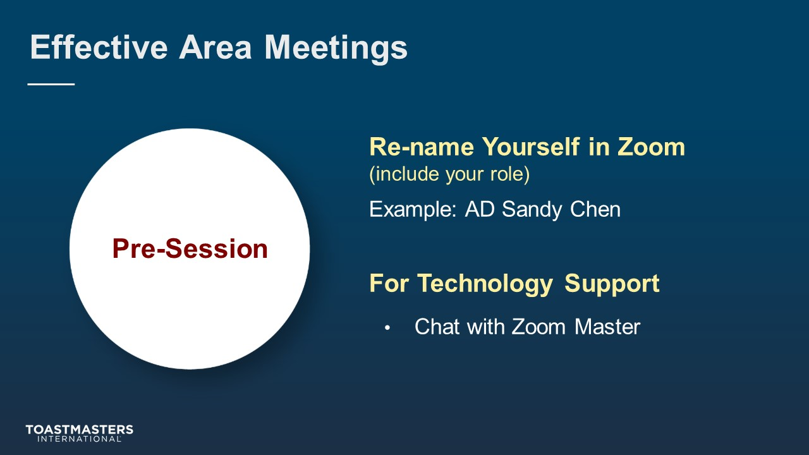
MONITOR Chat messages.

Introduction
(5 minutes)
note to facilitator
Use this time to introduce yourself formally to the Area Directors. A good introduction sets the tone for the session and highlights your experience and credibility. This is an excellent time to share a story related to the topic from your background as a Toastmasters member and leader. You may wish to share a story about a challenge you faced when you were facilitating a meeting. Or you could share, “What I wish someone had told me about facilitating meetings when I started my year as an Area Director.” Your goal is to connect them to the topic, to you, and to each other.
Throughout this session, it is essential to encourage Area Directors to use the pre-work insights and apply them to their current interactions.
The intent of this session is for Area Directors to look critically at meetings and how they can strategically plan meetings to contribute, facilitate, and lead more effective meetings as a team. When referring to meetings throughout the session, the focus is on business meetings.
The following slide should be updated to reflect where this session falls in your training program.
SHOW the Session Title slide.
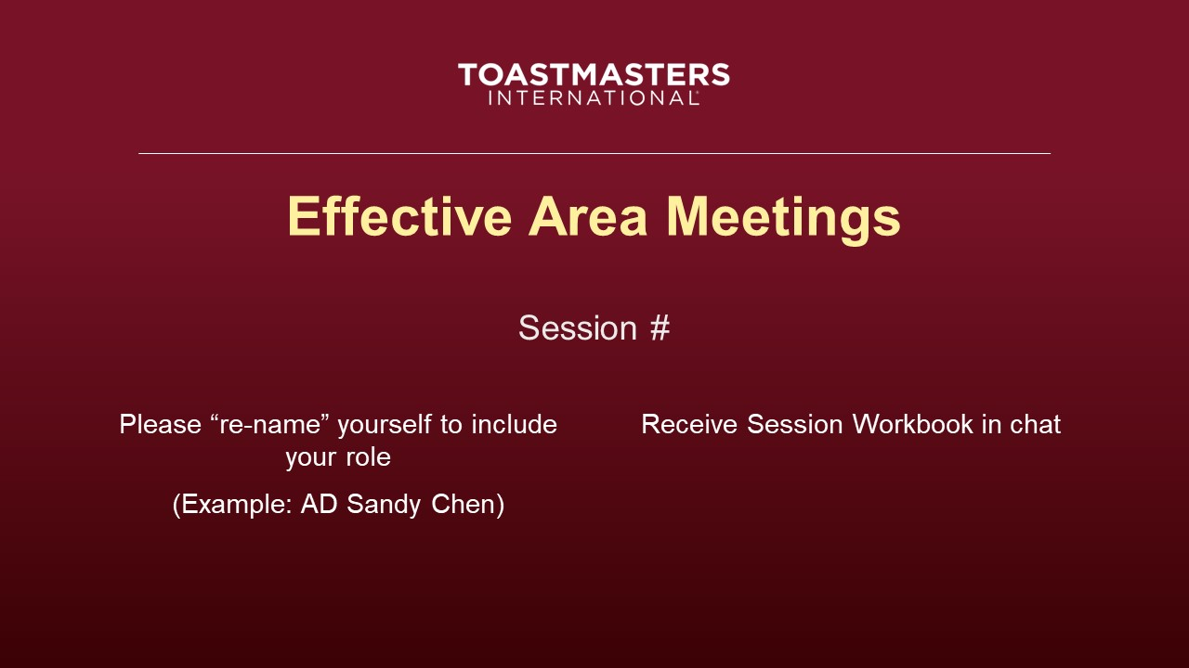
PRESENT
- Throughout the session, the meetings we will be referring to are business meetings.
- [insert your talking points here]
SEND session workbook to Area Directors in Chat.
SHOW the Agenda slide.
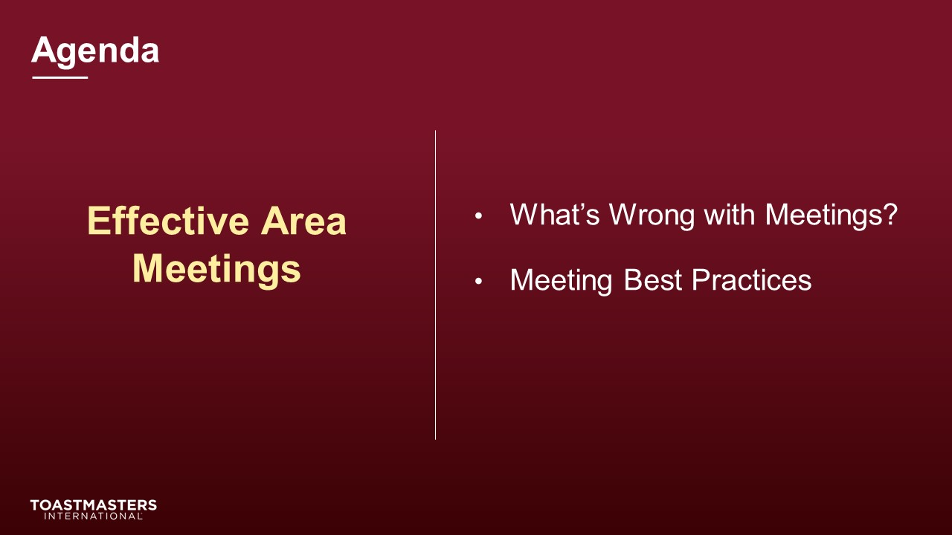
SHOW the Objectives slide.
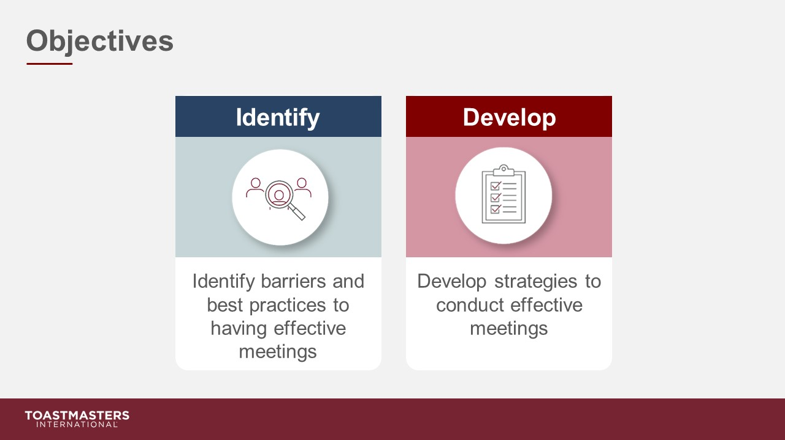

What’s Wrong with Meetings?
(20 minutes)
note to facilitator
Remind participants to open their pre-work so they can refer to their responses to questions. This will help guide their participation in the breakout room activity discussion.
The purpose of this section is to have participants brainstorm and discuss what makes a meeting ineffective.
PREPARE Breakout Rooms by randomly assigning a minimum of three and a maximum of four Area Directors to each room.
SHOW the Section Title slide.
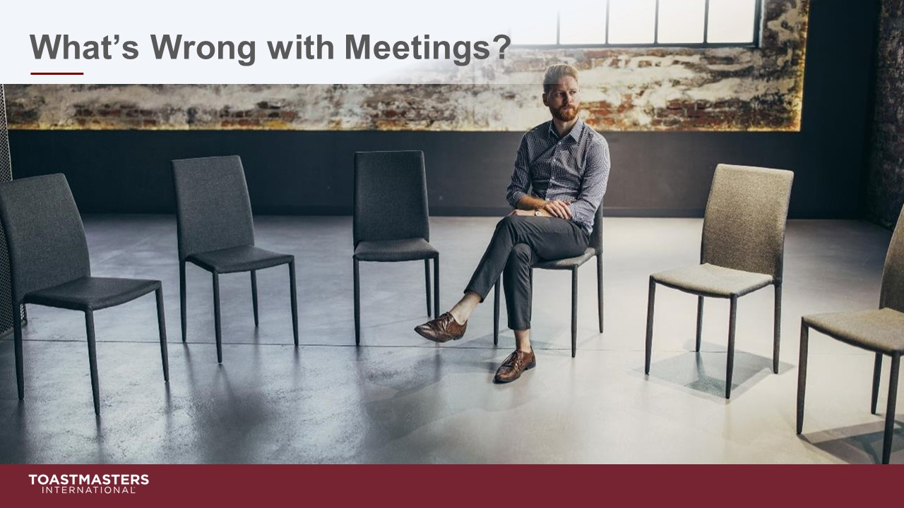
PRESENT
- [insert your talking points here]
SHOW the Breakout Room Activity slide.
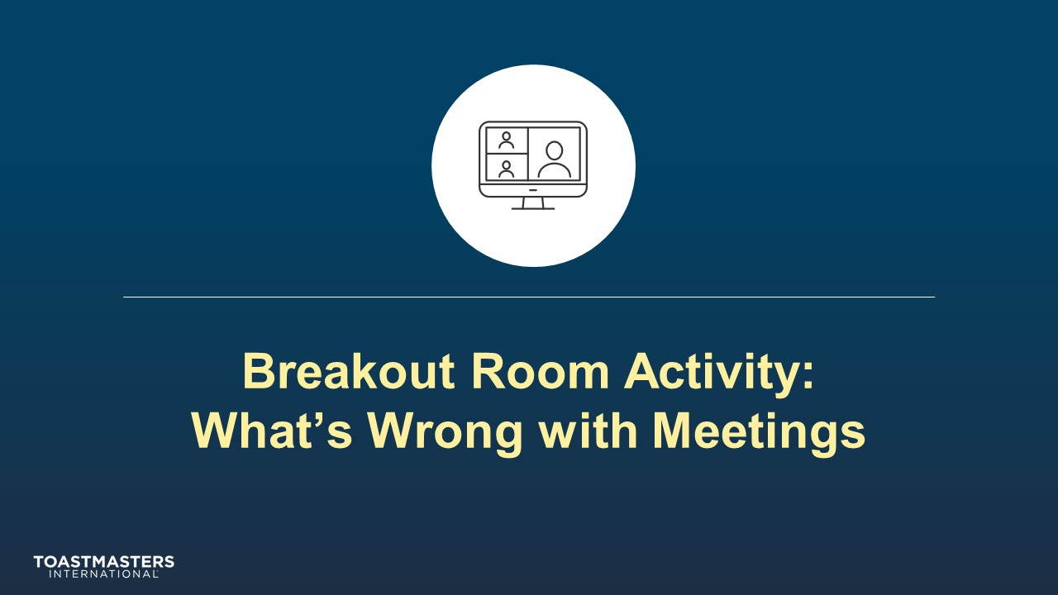
PRESENT
- [insert your talking points here]

note to facilitator
The following slide’s purpose is to remind Area Directors about a few of the tools available to them in the virtual Breakout Rooms. You may need to adjust these according to the platform that you are using to deliver this material. Plan to spend less than one minute on the next slide.
Ideally, you would like to see a minimum of three and a maximum of four Area Directors per group for this activity. Adjust group sizes and speaking time for each spokesperson to keep your session within the schedule parameters.
SHOW the Breakout Room Tips slide.
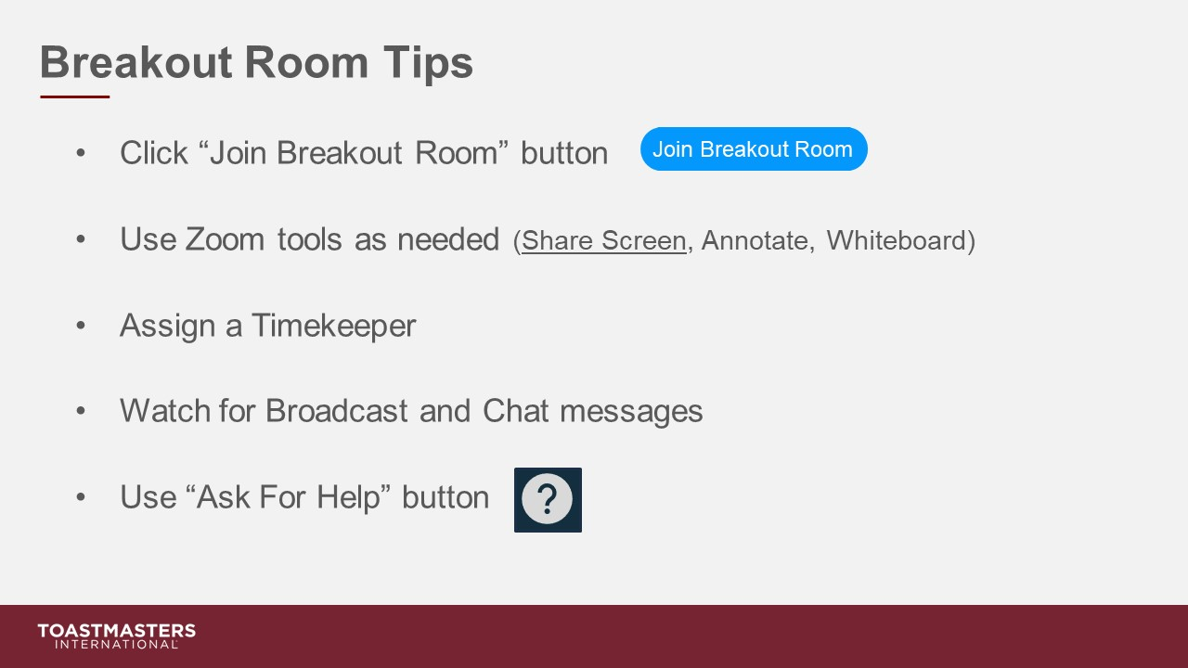
SHOW the Instructions slide.
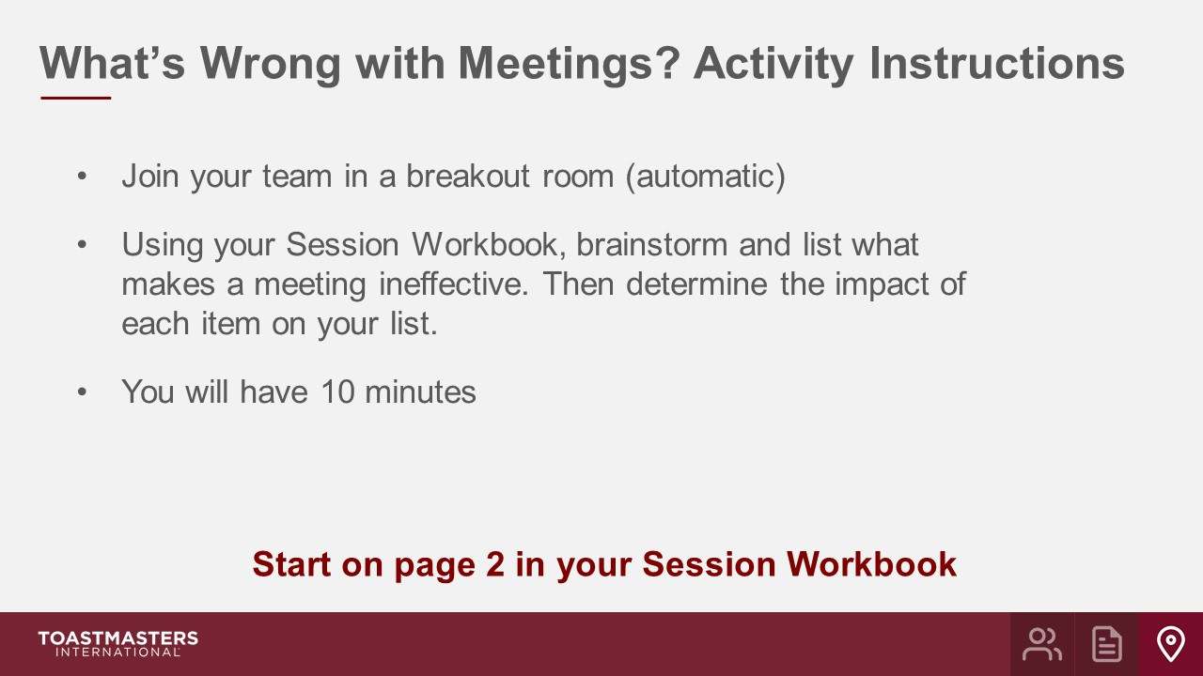
PRESENT
- We will send a two-minute warning before the end of the activity.
- I will be available to answer questions or provide assistance.
OPEN Breakout Rooms for activity (3-4 Area Directors per room).
MONITOR requests for assistance from Breakout Rooms.
VISIT Breakout Rooms to offer assistance and guidance, as needed.
SEND Broadcast after 5 minutes has elapsed: You have 5 more minutes.
SEND Broadcast after 8 minutes has elapsed: In approximately 2 minutes, you will be asked to return to the main session room.
CLOSE Breakout Rooms after 10 minutes.
SHOW the Whole Room Debrief slide.
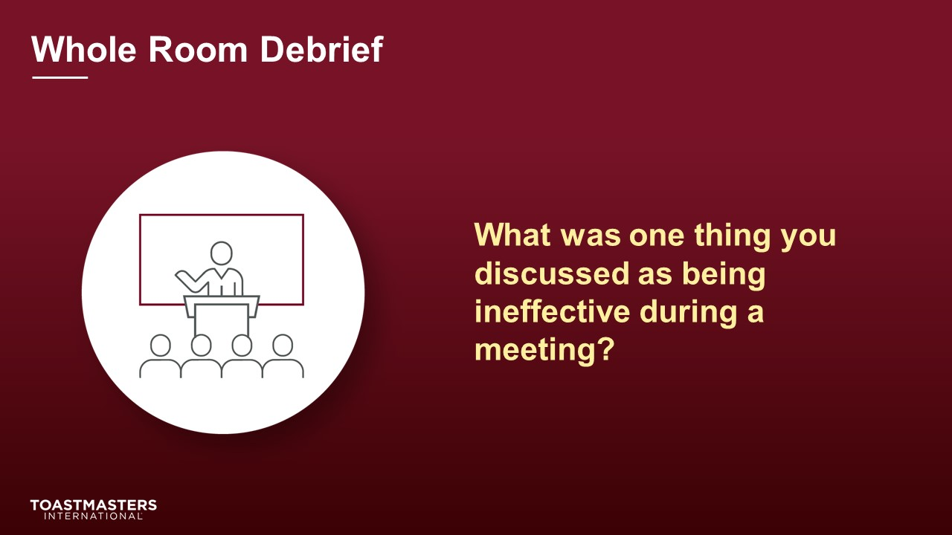
DISCUSS Area Director responses for 5-7 minutes.
SHOW the Present slide.
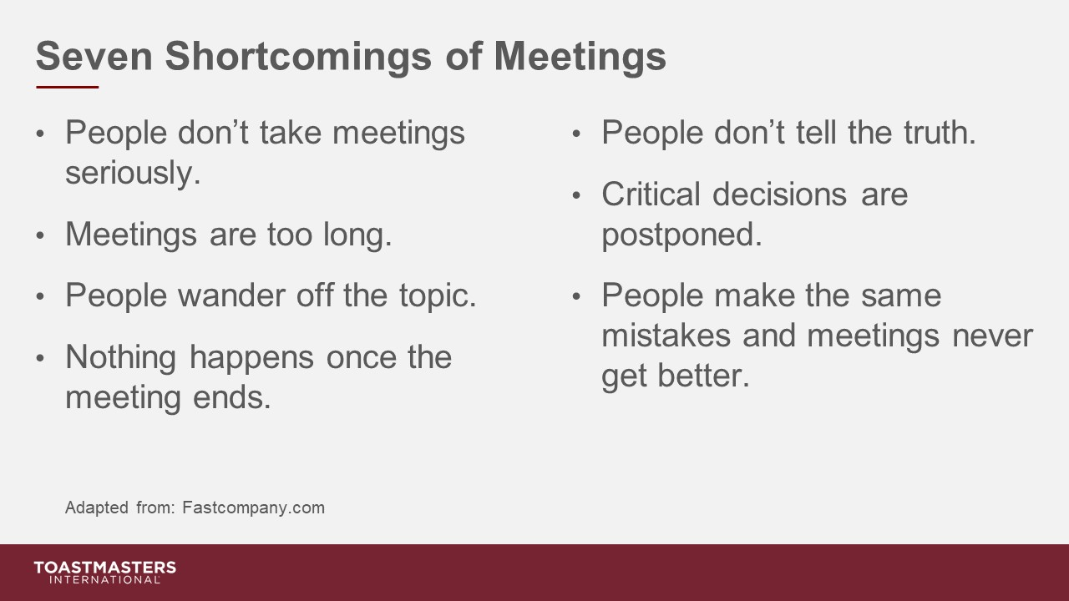
PRESENT
- [insert your talking points here]
SHOW the Review slide.
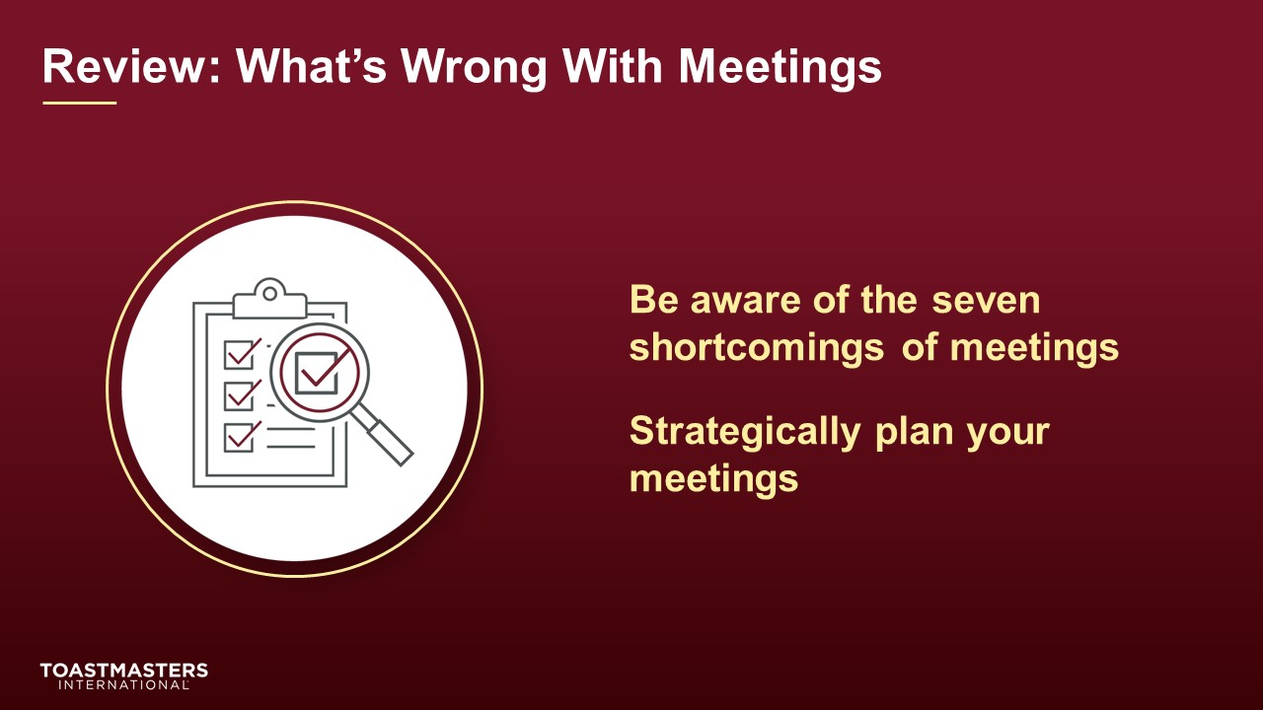
PRESENT
- [insert your talking points here]

Meeting Best Practices
(25 minutes)
note to facilitator
During this section, Area Directors will be assigned one of the seven shortcomings to discuss in a Breakout Room. The number of Breakout Rooms you need will depend on how many Area Directors you have in your session. For example, if you have more than 28 in attendance, you will need to assign the same shortcoming to more than one team. If you have fewer than 21 attendees, don’t assign all seven shortcomings.
SHOW the Section Title slide.
PRESENT
- [insert your talking points here]
SHOW the Breakout Room Activity slide.
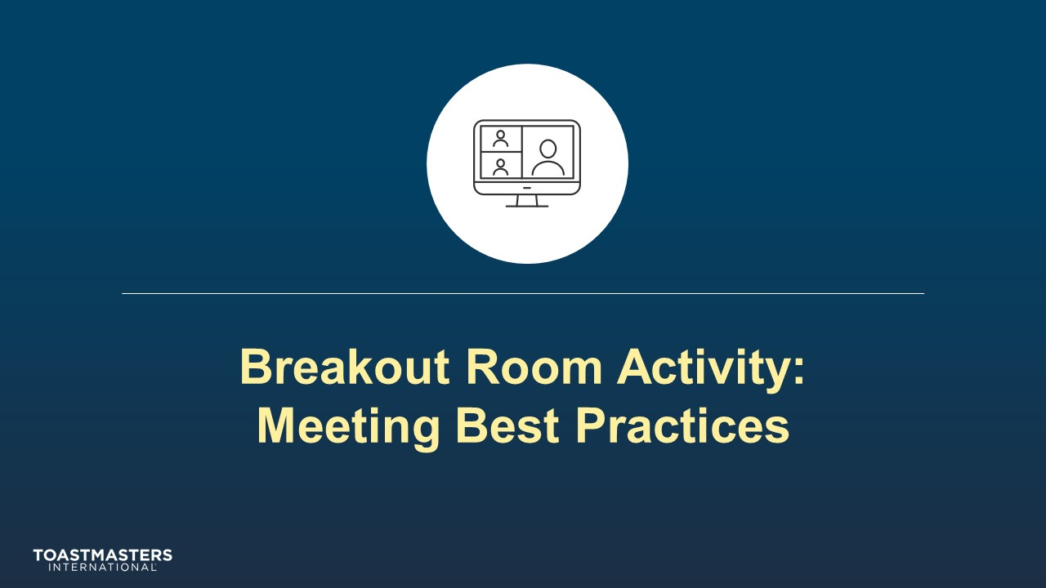
note to facilitator
The following slide’s purpose is to remind Area Directors about a few of the tools available to them in the virtual Breakout Rooms. You may need to adjust these according to the platform that you are using to deliver this material. Plan to spend less than one minute on the next slide.
SHOW the Breakout Room Tips slide.
SHOW the Activity Instructions slide.
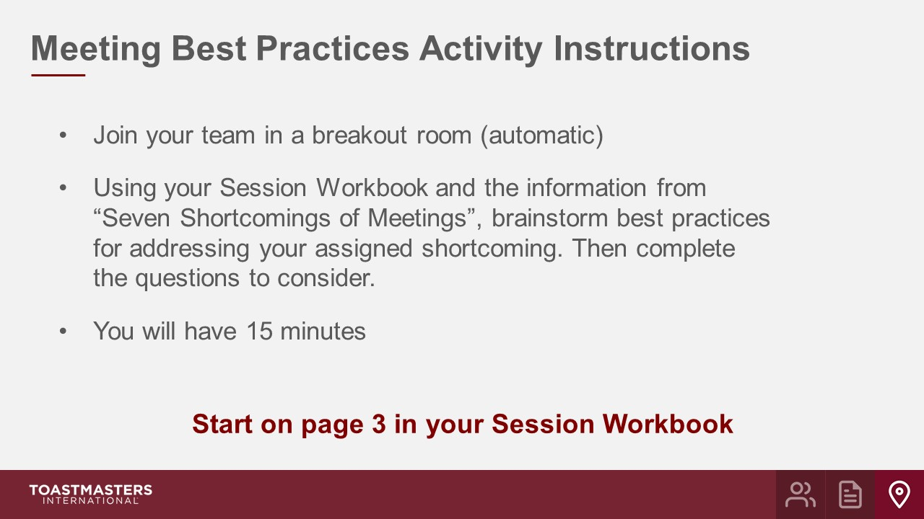
PRESENT
- We will send a two-minute warning before the end of the activity.
- I will be available to answer questions or provide assistance.
OPEN Breakout Rooms for activity.
MONITOR requests for assistance from Breakout Rooms.
VISIT Breakout Rooms to offer assistance and guidance, as needed.
SEND Broadcast after 10 minutes has elapsed: You have 5 more minutes.
SEND Broadcast after 13 minutes has elapsed: In approximately 2 minutes, you will be asked to return to the main session room.
CLOSE Breakout Rooms after 15 minutes.
SHOW the Whole Room Debrief slide.
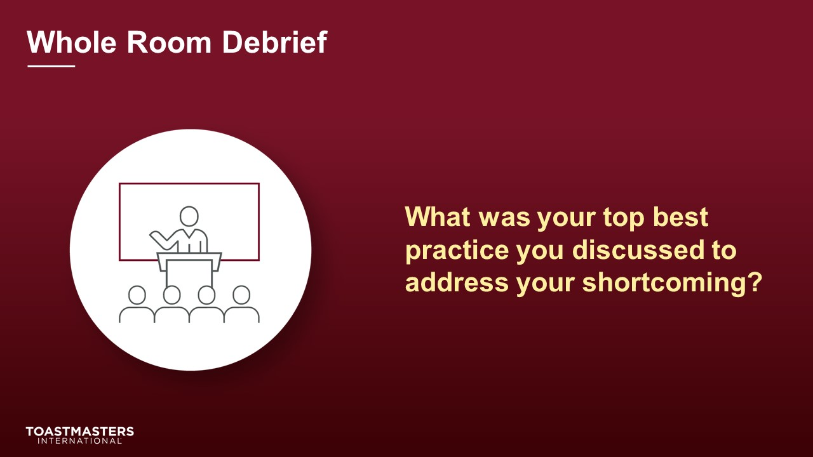
DISCUSS Area Director responses for 6 minutes.
SHOW the Review slide.
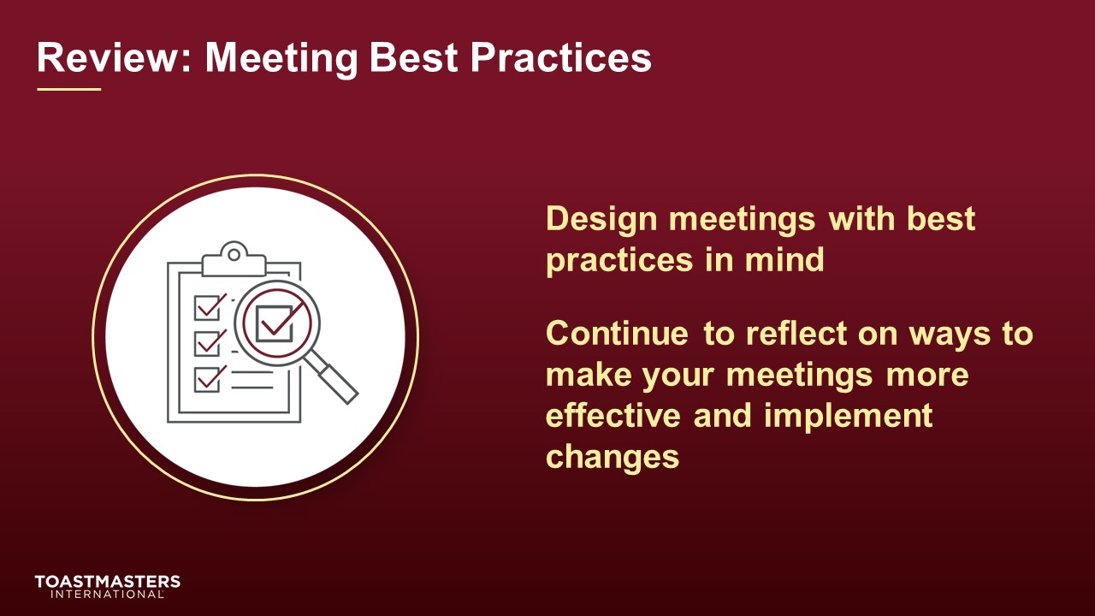
PRESENT
- [insert your talking points here]

Conclusion
(10 minutes)
SHOW the Conclusion slide.
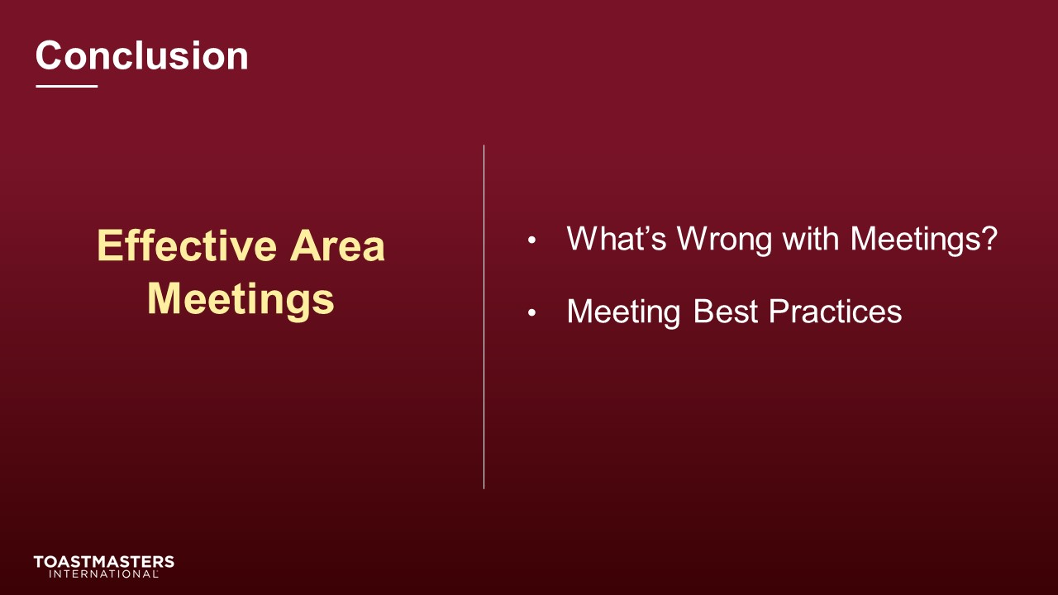
PRESENT
- There are additional resources available to you in your Session Workbook on page 5.
SHOW the Chat slide.
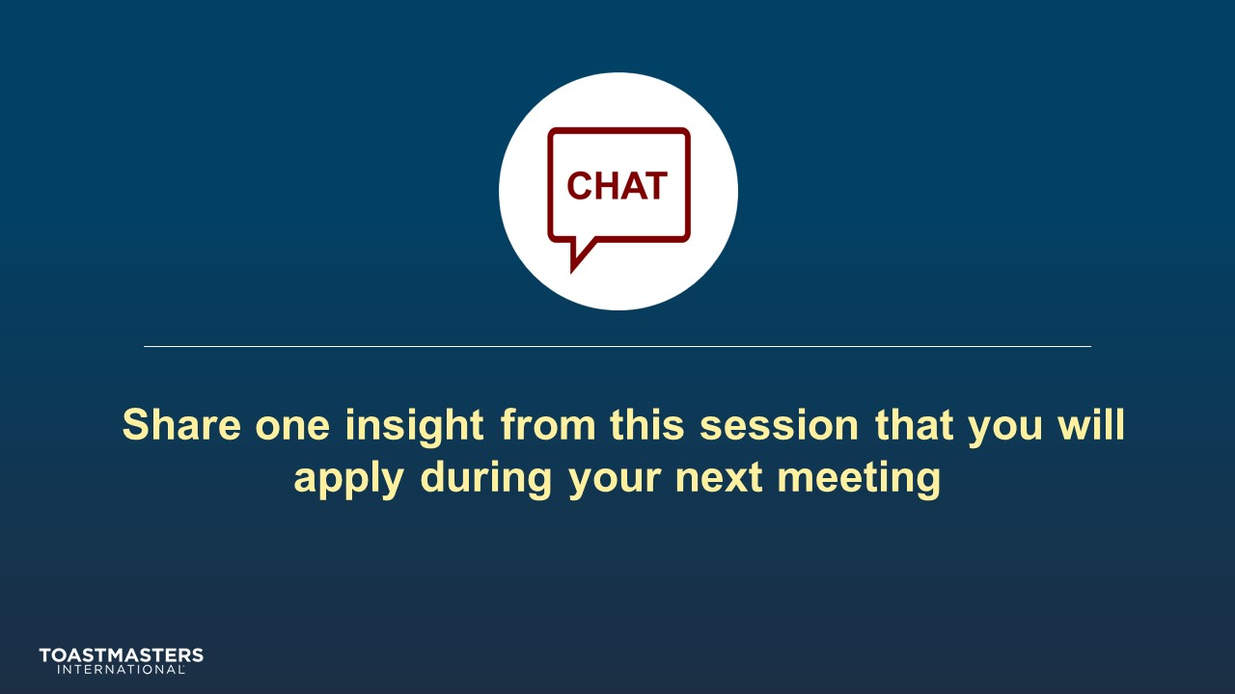
MONITOR Chat responses.
DISCUSS responses for up to two minutes.
note to facilitator
The following two slides should be edited to fit your requirements.
SHOW the Assessment slide.
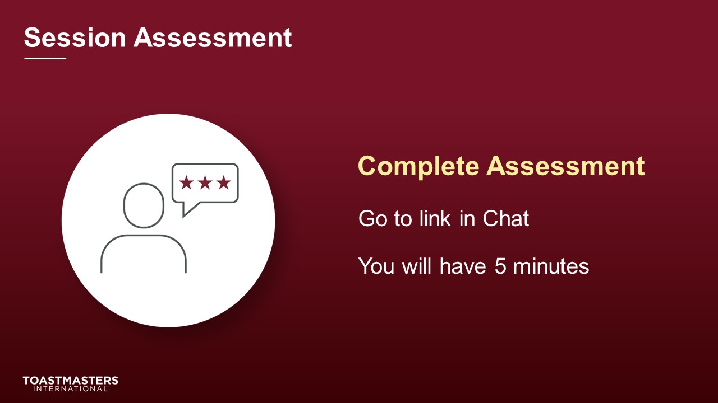
SEND Chat to Everyone: [insert link to assessment]
SHOW the What is Next slide.
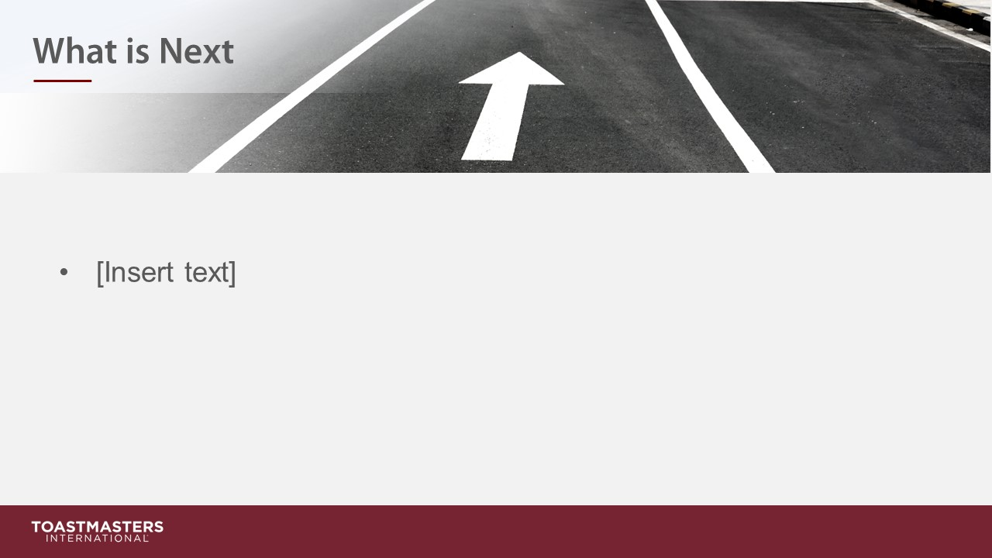
PRESENT
- [insert your talking points here]

